**EVENT REPORT**

**EXTEMPORE**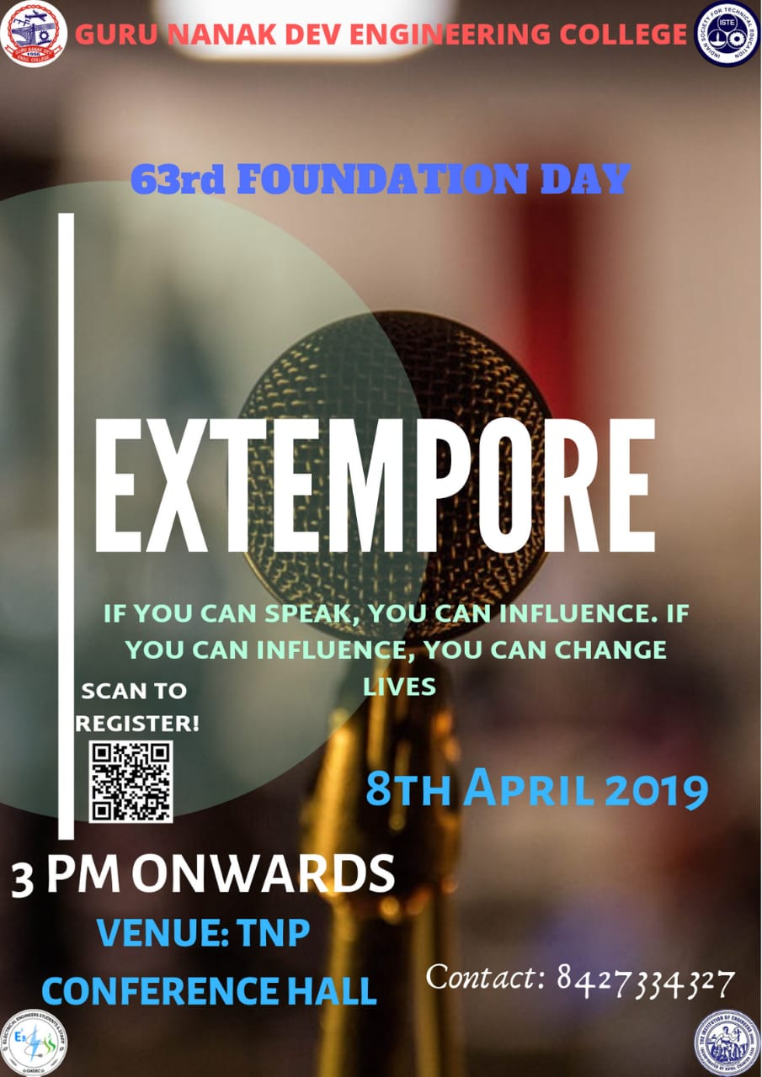

An event named Extempore was organized on **8 April 2019 from 3:00** **pm to 5:00 pm** in **TNP Conference Hall**. It was organized on the occasion of 63rd Foundation day of the institution. In the event, the participants were to pick a chit containing the topic from the bowl and were to speak on the technical topic for 1-2 minute. Prior 60 seconds were given to the participant to think on the topic. There was no language bar but bi–lingual was not permitted. During the extempore, first Bell rang at 1:30 min and then participants were to wind up within 30 seconds. Exceeded time lead to disqualification of the participant. The decision by judges was considered as final verdict. The complete event was interesting.

**Judging Criteria**: Participants were judged on their:

1)Content (Ideas, Logic & Effectiveness)

2)Presentation Style (Delivery, Body Language)

3)Organization and Clarity (Topic Development, Grammar, Pronunciation)

**LIST OF ORGANIZERS**

|  |  |  |  |
| --- | --- | --- | --- |
| **S.NO** | **NAME** | **BRANCH** | **ROLL.NO** |
| 1 | DIVYA NOOR | D3 CSE | 1606670 |
| 2 | AVI SEHGAL | D3 CSE | 1606655 |
| 3 | DARSHPREET SINGH | D3 CSE | 1606668 |
| 4 | SHUBHAM BARANWAL | D3 IT | 1607156 |
| **5** | SHIVAM SHRIVASTAVA | D3 IT | 1607155 |
| 6 | PARNEET KAUR | D2 CSE | 1706486 |
| **7** | ISHPREET KAUR | D2 CSE | 1706443 |
| **8** | KAMYA ARORA | D2 CSE | 1706453 |

**WINNERS LIST**

|  |  |  |  |
| --- | --- | --- | --- |
| **S.NO** | **NAME** | **BRANCH** | **ROLL.NO** |
| 1 | **AKSHAY SONI** | **D2 ME** | **1706943** |
| 2 | **SIDAK SINGH** | **D3 ME** | **1607355** |
| **3** | **NAVDEEP SINGH** | **D3 CSE** | **1606730** |
| 4 | **TARANDEEP SINGH** | **D1 ME** | **1805718** |

**PARTICIPANTS LIST**

|  |  |  |  |
| --- | --- | --- | --- |
| S.NO | NAME | BRANCH | ROLL.NO |
| 1 | TARANDEEP SINGH | D1 ME | 1805718 |
| 2 | MANPREET KAUR | D1 CSE | 1805200 |
| 3 | SIMRANJIT KAUR | D1 CSE | 1805992 |
| 4 | DOLLY | D1 IT | 1805504 |
| 5 | NAVDEEP SINGH | D3 CSE | 1606730 |
| 6 | SIDAK SINGH | D3 ME | 1607355 |
| 7 | JASKARAN SINGH | D4 CSE | 1507594 |
| 8 | PAWANDEEP SINGH | D4 CSE | 1507637 |
| 9 | BINAY RANJAN | D4 ME | 1508229 |
| 10 | AKSHAY SONI | D2 ME | 1706943 |
| 11 | PUSHKAR KUMAR | D3 CSE | 1606743 |
| 12 | SHUBHENDRA KUMAR | D2 CE | 1706310 |
| 13 | KAVISH THAKUR | D1 IT | 1821104 |

